

Director’s Profile 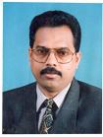

B. GOPAKUMAR, Director, Target Logistics Qatar WLL

An innovative expert, wizard and stalwart in Logistics Industry.

Gopakumar is rated as one of the top personalities in the Logistic Industry among GCC countries.

- Started his career with Logistics and Cargo in
Saudi Arabia with AL SUHAMI CARGO, DAMMAM,

SAUDI ARABIA and worked as Manager for 10 years
from 1985 to 1995 and steered the Company to heights.

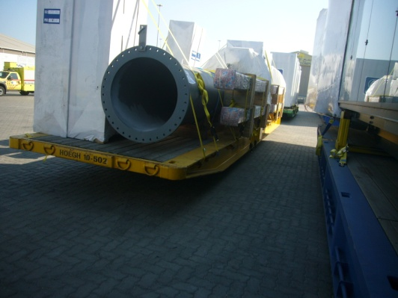

          - Joined as Country Manager in American Airlines
in 1995 and initiated and stabilized Cargo Division.
Instrumental in elevating the Company to one of the
biggest Cargo Companies in Qatar.
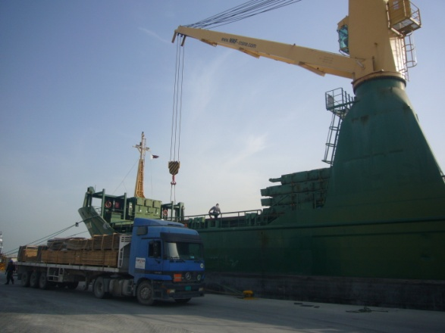

- Worked with Overseas Cargo as General Manager
for 5 years from 2000-2005. During his tenure,
he established agency with the following
global freight forwarders:

- KINTETSU WORLD EXPRESS
- Eagle Global Logistics (Presently CEVA Logistics)
- SCHENKER (Included in Top 10 Freight Forwarders
in the world).

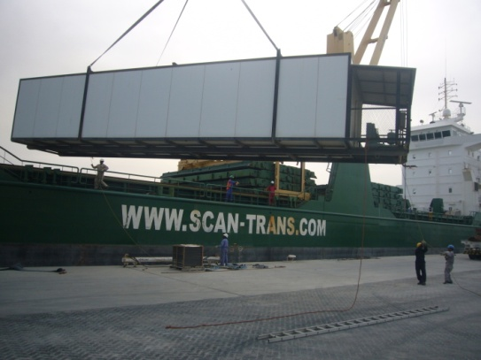

          - From 2005-2009 worked as
General Manager (Sales) in Airlink International ,
which played a very important role in one of the
biggest Sports events in the entire world-
DOHA ASIAN GAMES. Mr Gopakumar was
the man behind the success of organizing
and operating such a huge project.

Under the leadership of Gopakumar Company
handled gigantic oil and gas projects.
Successfully organized many Exhibitions
and Motor Shows where too Gopakumar
proved his skill and ability.

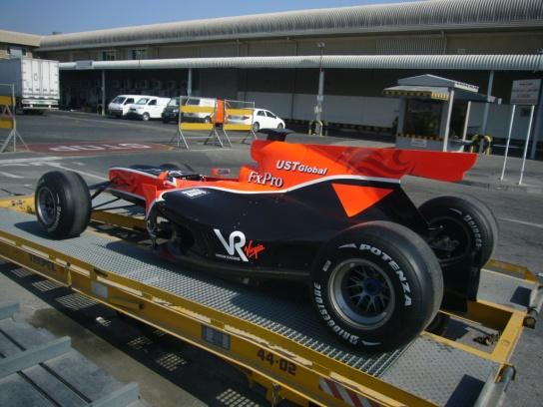

• In 2009, with the vast and rich experience
in the field of global logistics and freight forwarding,
Mr Gopakumar decided to directly apply his
entrepreneurial skills in his own Company, and formed
Target Logistics Qatar WLL which is one of the
premier Logistic Companies in Qatar now.
Mr Gopakumar and his very able and vibrant team,
under his efficient leadership, has
diversified their operations into
Transportation and warehousing
as well, thus completing the vicious circle
of global freight forwarding. 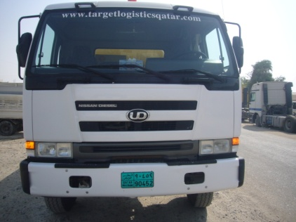

• The Company has taken up massive projects with the biggest
corporate in the country, Qatar Petroleum . Handled huge shipments of Airport construction materials, mainly Airway bridges, for construction of New Doha International Airport
in liaision with Thyssen Krupp, one of the biggest Airport
Construction specialists in the world.
Project and Exhibition cargo has been the speciality
of the Company, with Mr Gopakumar at the
apex level of planning and co-ordination.

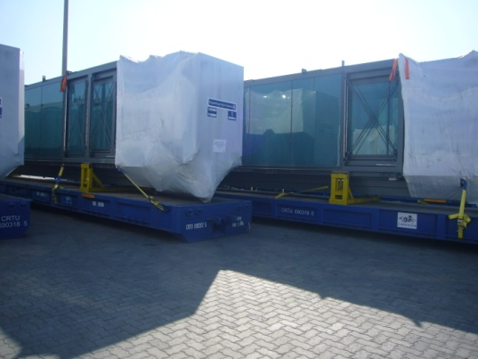

• Mr Gopakumar has visualized the scope of Logistics in Qatar
in view of the forthcoming and biggest sports event
in the whole world-The World Cup Football to be hosted
by Qatar in the year 2022 and he is gearing up towards
raising the standards of his Company ,to cope up and
compete with global giants in the similar field.

